1. One of the easiest and great ways to get a feel of the entire Oauth protocol and also see it in action is by going to the Google Oauth Playground.
2. 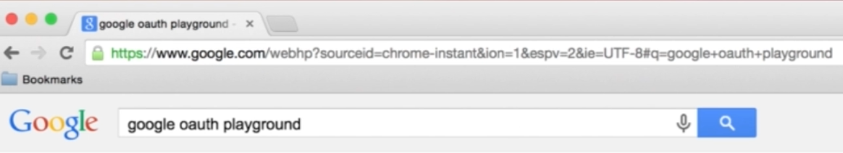
3. 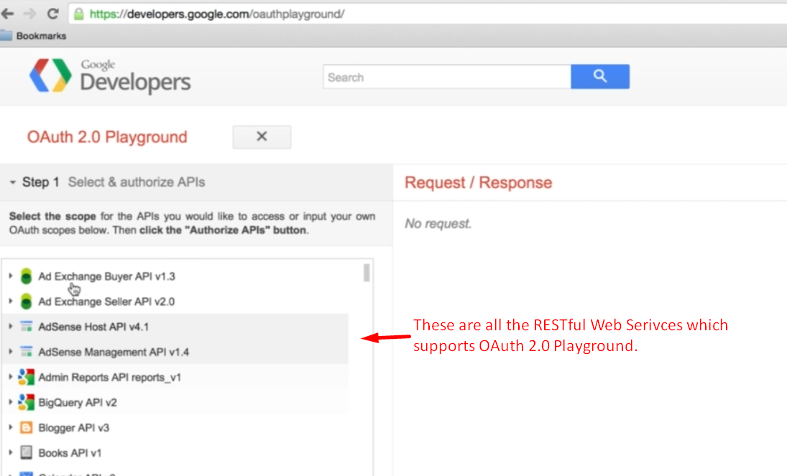
4. 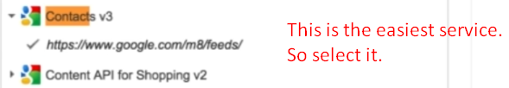
5. 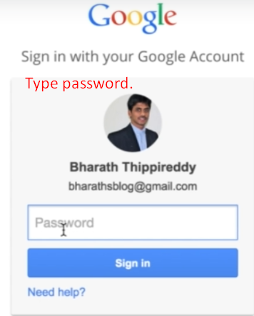
6. 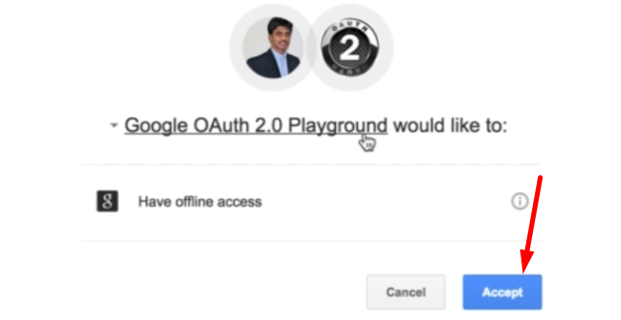
7. 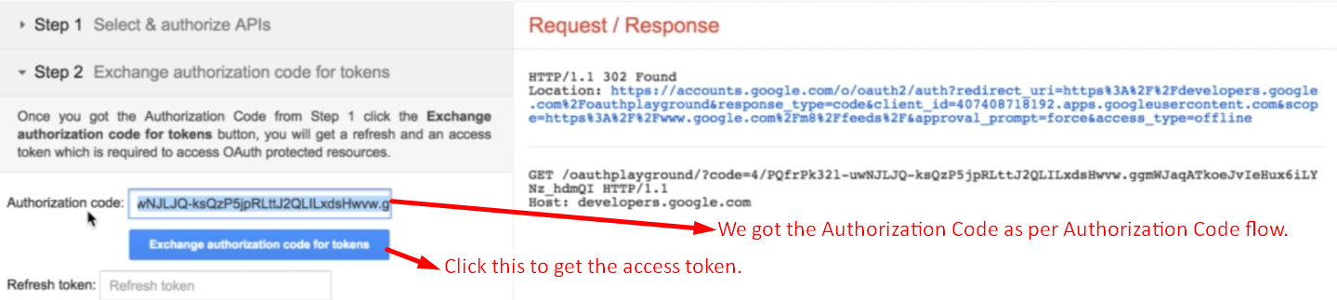
8. 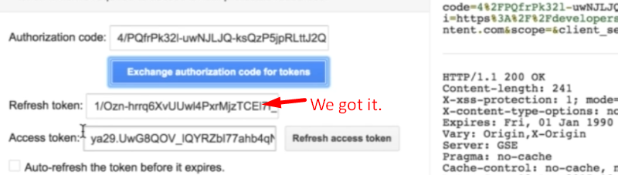
9. 